Activity 10-1 – Installing Internet Information Services (IIS)
Step-1
1. Opened Control Panel
I went to Control Panel → Programs.
2. Opened Windows Features
Inside Programs and Features, I clicked Turn Windows features on or off.
A UAC message popped up, and I clicked Continue.
Inside the Windows Features window, I did the following:
- Checked Internet Information Services.
- Expanded the IIS folder.
- Expanded World Wide Web Services and made sure these were checked:
  - Application Development Features (including all ASP and ASP.NET options)
  - Common HTTP Features
  - Security
- Expanded Web Management Tools and ensured:
  - IIS Management Console
  - IIS Scripts and Tools
were selected.
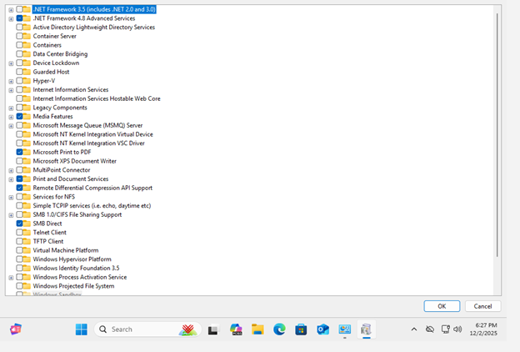
3. Installed IIS
I clicked OK. Windows installed the required components. When I saw Windows completed the requested changes, I clicked Close.
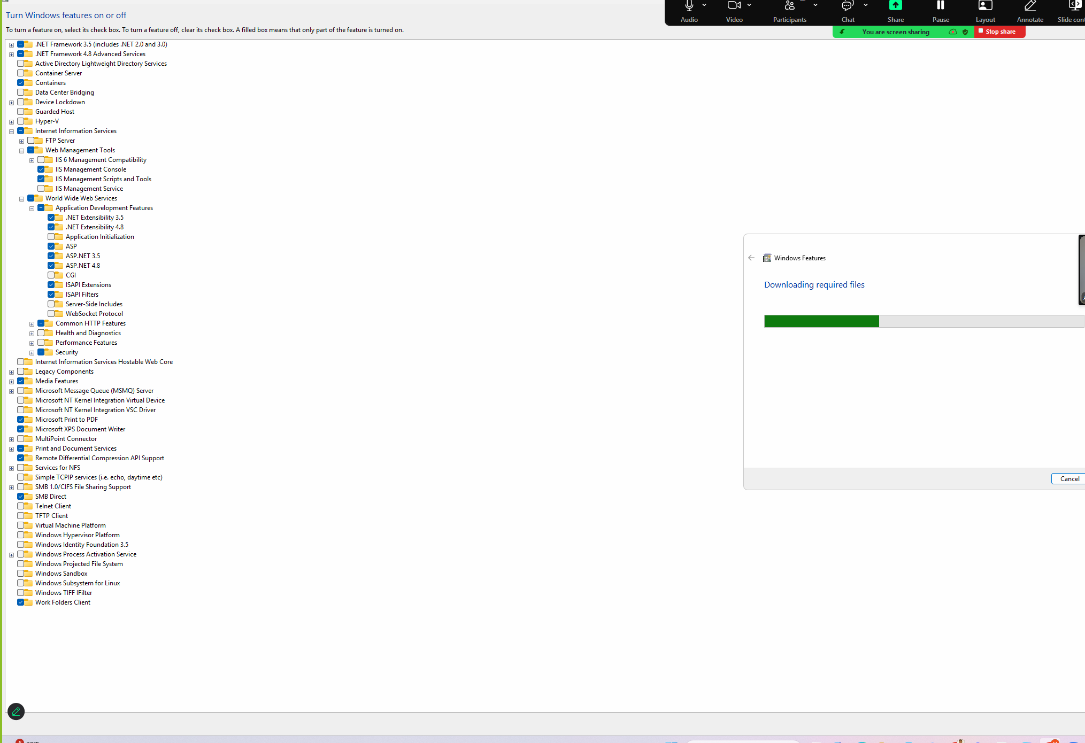
4. Verified IIS Installation
I clicked Start, typed inetmgr, and pressed Enter.
This opened IIS Manager. In IIS Manager, I clicked Help → About Internet Information Services to check the installed IIS version.
5. Tested IIS in Browser
I opened my web browser and entered:
http://localhost
The IIS Welcome Page appeared, confirming the web server was running correctly.
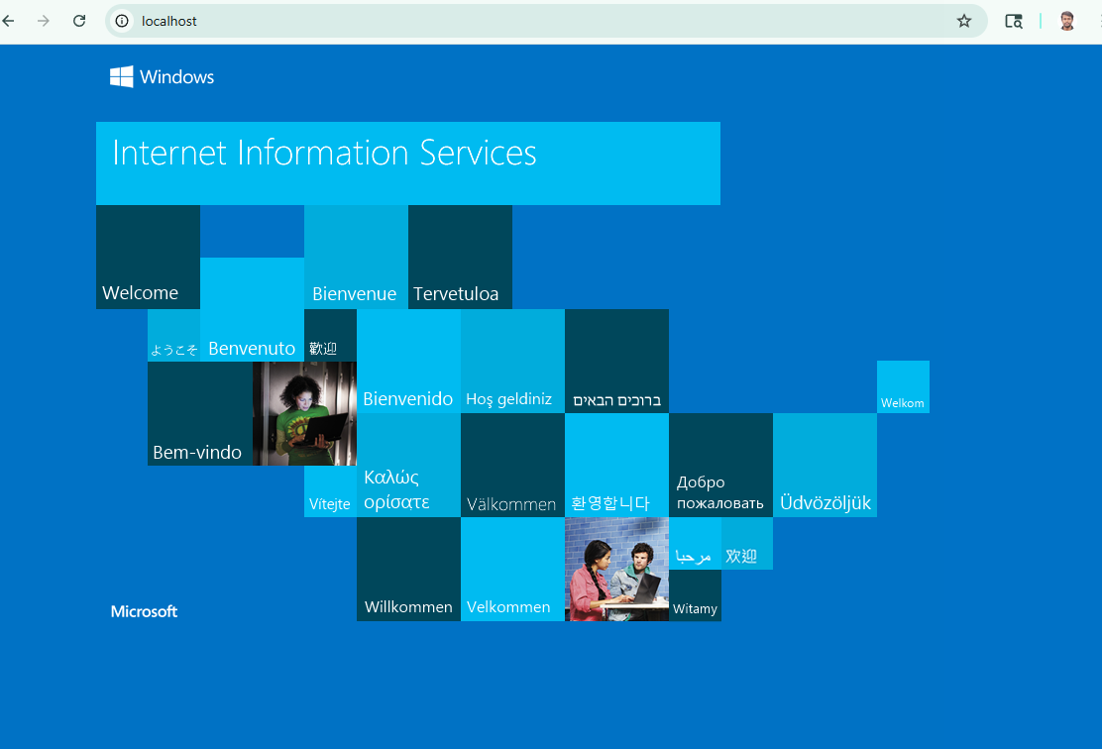
6. Opened the Web Root Folder
I opened File Explorer and navigated to:
C:\inetpub\wwwroot
This is the default location where IIS stores website files.
7. Created My Own Folder
Inside wwwroot, I right-clicked → New → Folder.
I named the folder: YourFirstName
8. Closed Windows
I closed all open windows and left Windows running for the next activity.

Activity 10-2 Report: Creating a Virtual Directory
Steps I
1. Opened IIS Manager
- I clicked Start.
- Typed inetmgr.
- Pressed Enter to open IIS Manager.
Inside IIS Manager, I expanded the following in the Connections pane (as shown in Figure 10-4):
- My computer name
- Sites
- Default Web Site
This showed me the folder I created earlier in A
2. Added the Virtual Directory
- I located my folder (YourFirstName, in my case Azizul) under Default Web Site.
- I right-clicked my folder.
- Selected Add Virtual Directory.
3. Configured the Virtual Directory
In the window that appeared:
- In Alias, I typed my first name (example: Azizul).
This is the name users will see in the URL.
- In Physical path, I selected:
C:\inetpub\wwwroot\YourFirstName
(In my case: C:\inetpub\wwwroot\Azizul.)
- I clicked OK to finish creating the virtual directory.

4. Finished
I closed all open windows and left Windows running for the next activity.

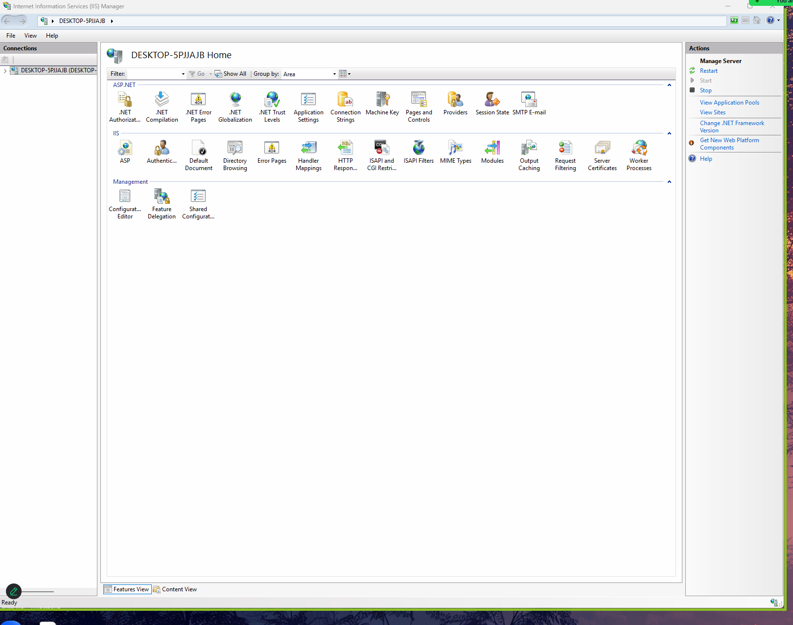

2. Added the Virtual Directory
- I located my folder (YourFirstName, in my case Azizul) under Default Web Site.
- I right-clicked my folder.
- Selected Add Virtual Directory.

Activity 10-3 Report: Creating an ASP.NET Webpage

Steps
1. Started Notepad as Administrator
- I clicked Start.
- Typed Notepad.
- Right-clicked Notepad.
- Selected Run as administrator.
- If UAC popped up, I clicked Yes.
Inside Notepad, I typed the ASP.NET code provided in the activity.
2. Saved the File as an ASP.NET Page
- I saved the file as First.aspx.
- Location:
C:\inetpub\wwwroot\YourFirstName
(In my case: C:\inetpub\wwwroot\Azizul.)
- I made sure the extension was .aspx, NOT .txt.
- Then I closed Notepad.
- 3. Tested the Webpage in a Browser
- I opened my web browser and typed the URL:
- http://localhost/YourFirstName/First.aspx
- Example for me:
- http://localhost/Azizul/First.aspx
- When the page loaded, it displayed the current date and time.
This confirmed that the ASP.NET code was running dynamically on the server.
- The <% %> tags in the page tell IIS to execute code and then return the result to the browser.

4. Viewed the Page Source
- I right-clicked the webpage.
- Selected View page source.
I noticed that the ASP.NET code did not appear in the source.
This is because the server executes the code before sending HTML to the browser.
This also proves that ASP.NET is a server-side scripting technology.
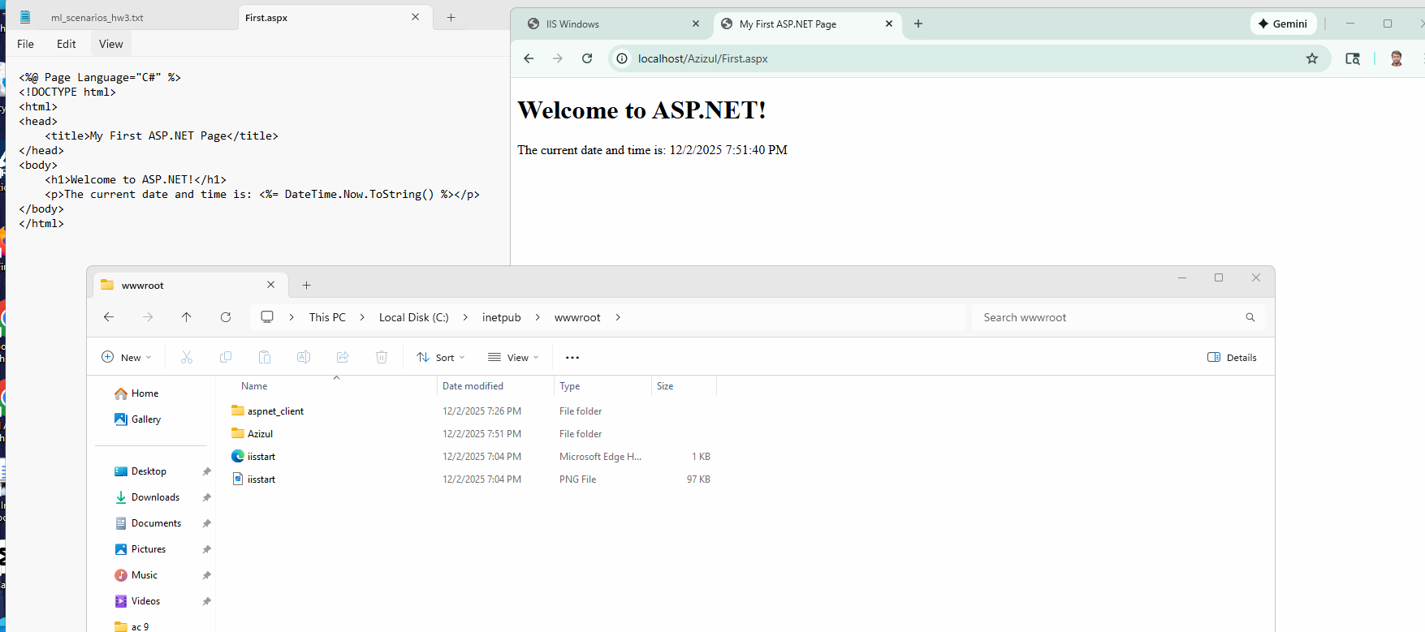

5. Finished the Activity
I closed the browser and logged off Windows to prepare for the next activity.

Activity 10-4 Report: Working with Apache Web Server
Steps
1. Booted into Kali Linux
I started my Kali Linux VM and made sure I was logged into the desktop environment.

2. Started the Apache2 Service
I opened the Terminal and typed:
sudo systemctl start apache2
If Apache didn’t start because nginx was running, the steps were:
sudo systemctl stop nginx
sudo systemctl start apache2
Then I confirmed Apache was running:
systemctl status apache2
It showed active I mean running.
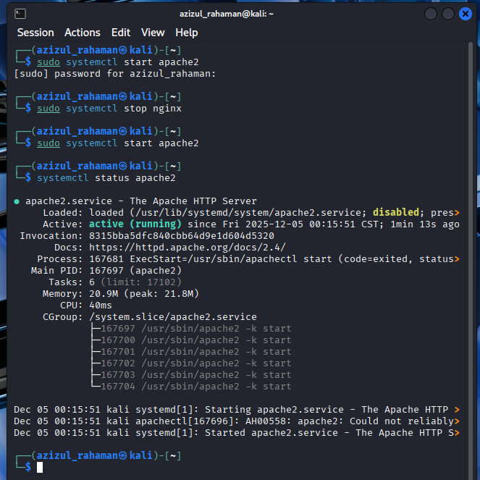
3. Opened the Browser and Viewed the Apache Default Page
- I opened Firefox/Chromium in Kali.
- Typed: localhost
The page showed the default Apache configuration info.
4. Stopped Apache
Back in Terminal:
sudo systemctl stop apache2
5. Viewed Apache Configuration Files
I moved into the Apache config directory:
cd /etc/apache2
Then used grep to find included configuration paths:
grep Include apache2.conf
From the output, I noticed:
IncludeOptional sites-enabled/*.conf
This means Apache loads website config files from /etc/apache2/sites-enabled/.
6. Listed Active Site Configurations
I typed:
cd /etc/apache2/sites-enabled && ls
It showed 000-default.conf, the main site configuration file.
Opened the Site Configuration File
I edited the file using gedit:
I used sodu vim because sudo gedit 000-default.conf not support
8. Added Authentication Configuration
At the bottom of the file, under:
</VirtualHost>
I inserted the required configuration block to enable password protection for a directory. Then I saved and closed.
9. Created a Restricted Directory
Back in Terminal:
sudo mkdir /var/www/html/restricted
10. Created a Test File Inside Restricted Directory
I entered the directory:
cd /var/www/html/restricted
Then created a file:
sudo touch secret.txt
This will be the file users access only after authentication.
11. Created the .htaccess File
Still in the restricted directory:
sudo vi .htaccess
Inside vi, I typed i to enter insert mode and added the authentication rules (as given in the activity).
Then I saved and exited:
- Press Esc
- Type: :wq!
- Press Enter

12. Created a Password File
In Terminal:
sudo htpasswd -c /etc/apache2/.htpasswd tester
I entered and confirmed a password for user tester.
Apache will use this file to validate credentials.
I checked the file:
cat /etc/apache2/.htpasswd

13. Restarted Apache
To activate the new configuration:
sudo systemctl restart apache2

14. Tested the Restricted Directory
In the browser, I typed:
http://localhost/restricted
Apache asked for:
- Username: tester
- Password: the one I created
After logging in, the file secret.txt was displayed.
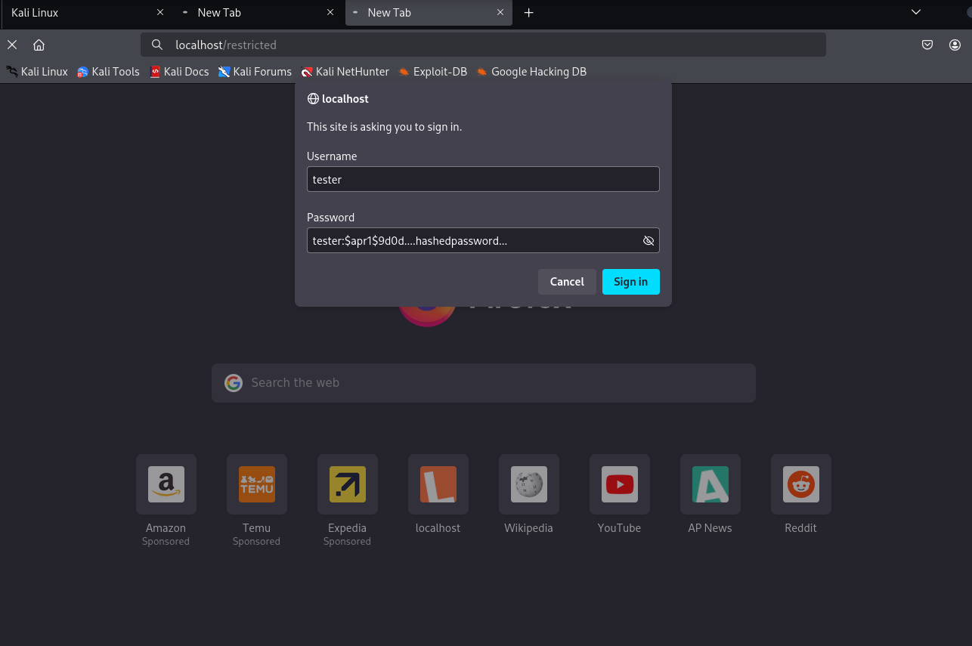
15. Tested Access from Another Device
I found my machine’s IP:
ifconfig eth0
On another device, I typed:
http://yourIPaddress/restricted
It also asked for login credentials.

16. Question: Why is Login Without SSL a Problem?
Because the username and password are sent in clear text, anyone on the network can sniff and steal the credentials.
Fix:
Use HTTPS (SSL/TLS) so credentials are encrypted.

17. Problems with Basic Authentication
After researching:
- Basic authentication sends credentials base64-encoded (NOT encrypted).
- Easy for attackers to intercept.
- Works only safely when combined with HTTPS.
- Credentials are cached in the browser.

18. Closed Everything
I closed:
- Terminal
- Web browser
- Logged off Kali Linux
This completed the activity.

Activity 10-5 Report
Step 1: Visit the CVE Website
I opened my web browser and went to:
https://cve.mitre.org
Step 2: Search the CVE List
I clicked Search CVE List from the top navigation bar.

Step 3: Search for SQL Injection
In the search box, I typed:
SQL injection
Then I clicked Submit.
Number of CVE entries:
The list showed thousands of SQL injection CVEs (the exact number can change every day because new vulnerabilities are discovered continuously).
This shows that SQL injection is still one of the most common vulnerabilities on the internet.
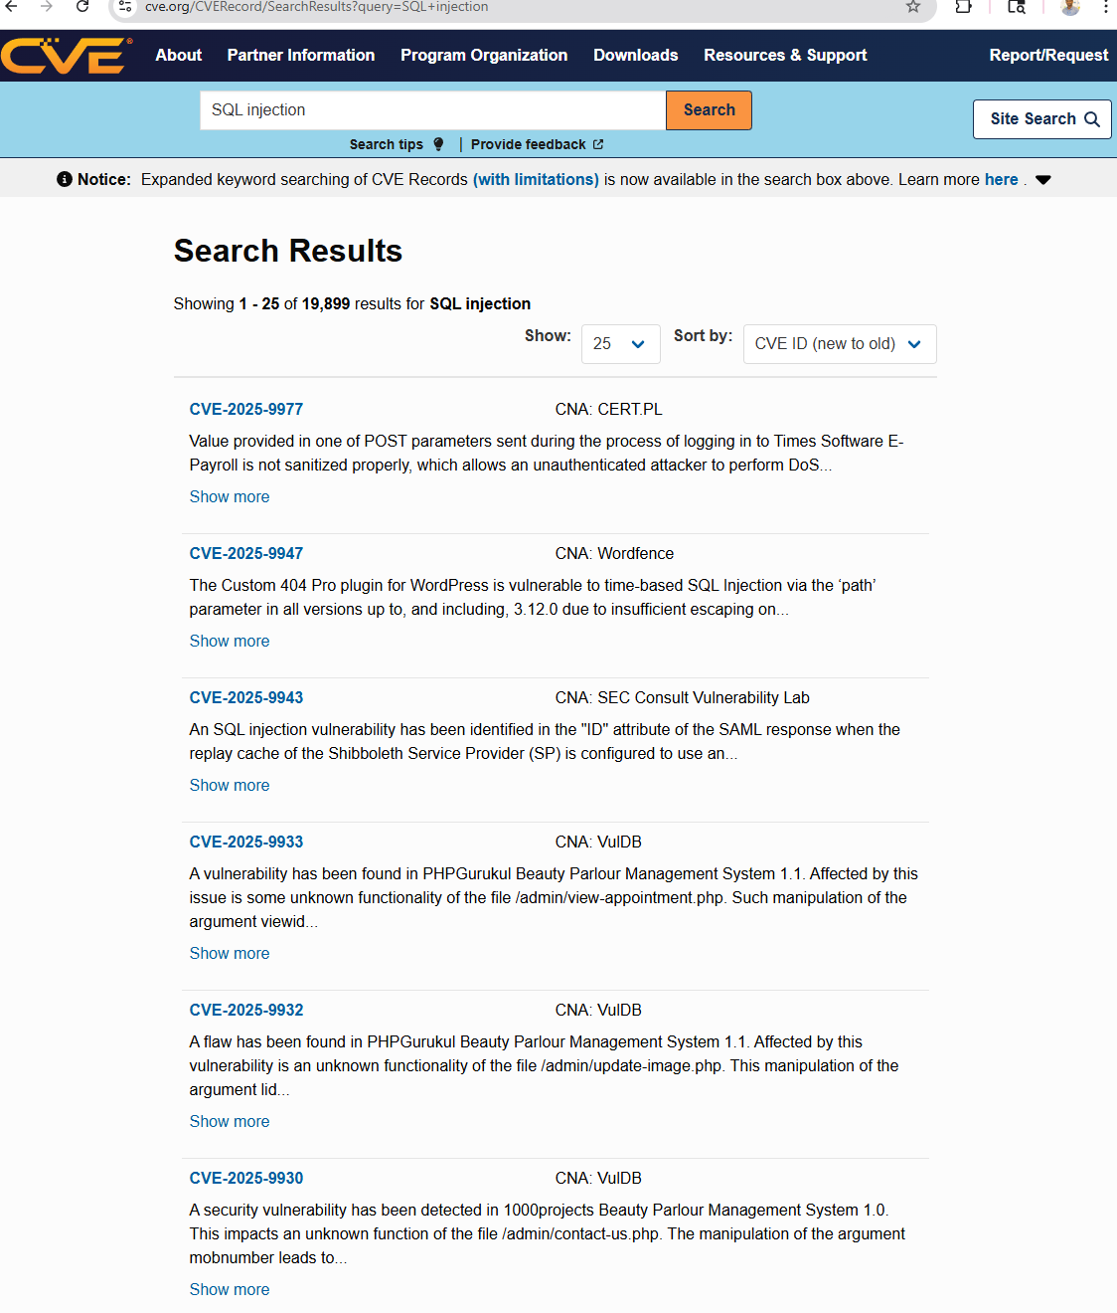

Step 4: Search for SQL Injection in phpBB
Next, I typed: SQL injection phpbb
Then clicked Submit.
The entries listed for phpBB SQL injection vulnerabilities were much fewer, but still showed several well-known CVEs affecting phpBB forums. Even though many are old, many websites still run outdated phpBB versions, so they may remain vulnerable.
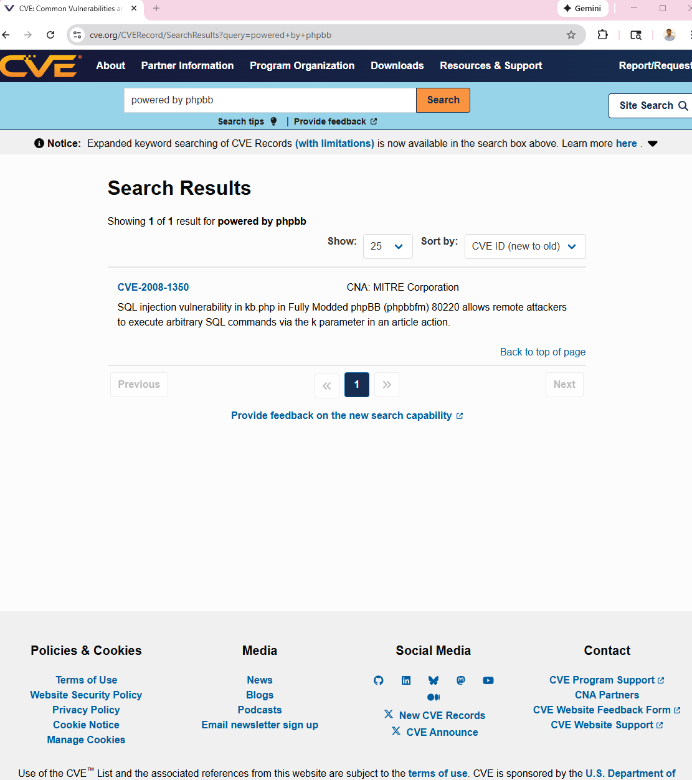

Step 6: Security Ramifications
Listing software versions publicly is risky because:
- Attackers can identify your technology stack instantly
They know exactly what software you are running.
- They can match the version to known vulnerabilities
Example:
If phpBB version 2.x is known for SQL injection issues, an attacker will immediately target you.
- Increases automated attacks
Bots constantly scan the web for these tags.
Step 7: Exit the Browser
I closed the browser as instructed.

Step 8: SQL Injection Vulnerabilities & WebGoat
1.Installing Docker
Before running WebGoat, Docker had to be installed since WebGoat runs inside a container.
I executed the following commands:
sudo apt update
sudo apt install docker.io
Docker and all required dependencies were installed successfully.
I verified the installation with:
sudo docker –version
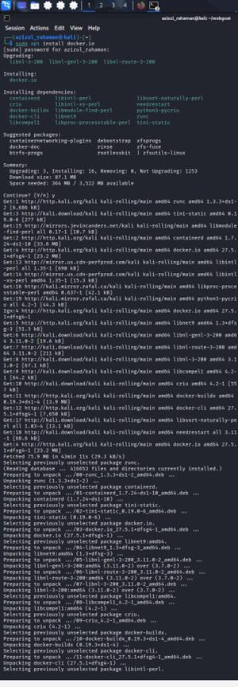
2. Pulling and Running WebGoat Container
Next, I downloaded the official WebGoat Docker image:
sudo docker pull webgoat/webgoat
Then I started the WebGoat server:
sudo docker run -p 8080:8080 -p 9090:9090 --rm webgoat/webgoat
If the container runs correctly, WebGoat and WebWolf start and display initialization messages.
This confirmed that the application was ready.

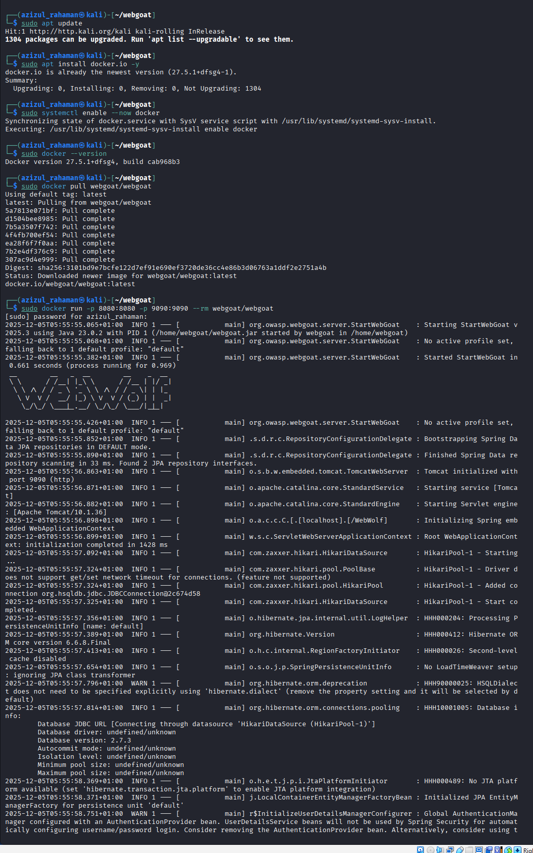
.3 Logging Into WebGoat
Using a web browser on Kali Linux, I visited:
http://localhost:8080/WebGoat
I logged in with:
- Username: webgoat
- Password: webgoat
WebGoat successfully opened and presented all lessons.
3. SQL Injection (Intro) Exercises Completed
The SQL Injection (Intro) module contains 13 tasks focused on understanding SQL commands and how attackers can manipulate input to harm a database.
I completed all the exercises step-by-step.

4.1 Understanding SQL Concepts
The introduction explained:
- DML, DDL, DCL
- Basic SQL syntax
- String and numeric SQL injection
- How SQL injection affects the CIA triad
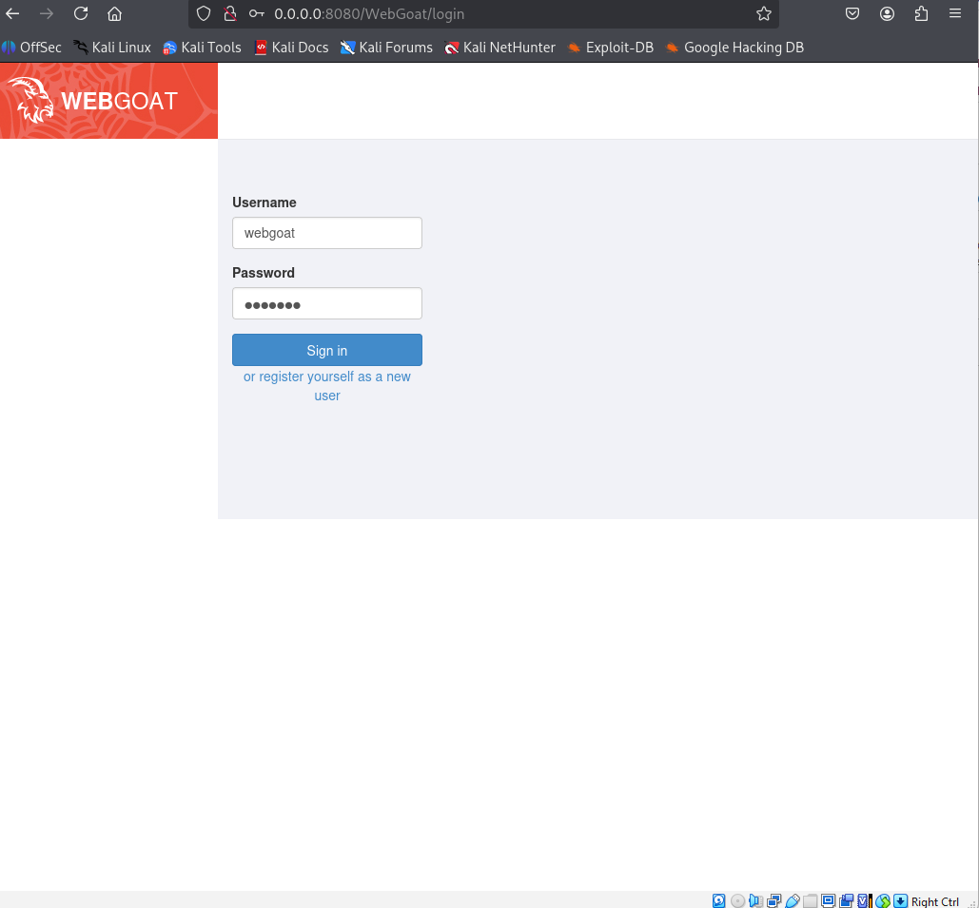
3.2 Practical SQL Injection Tasks
Confidentiality Attack
I learned how SQL injection can expose sensitive information, such as user lists or login credentials.
Example: Injecting a condition like:
' OR '1'='1
to bypass authentication or read data.

Integrity Attack
Here I learned how attackers can modify database entries.
Example: Updating or altering data through injected queries.
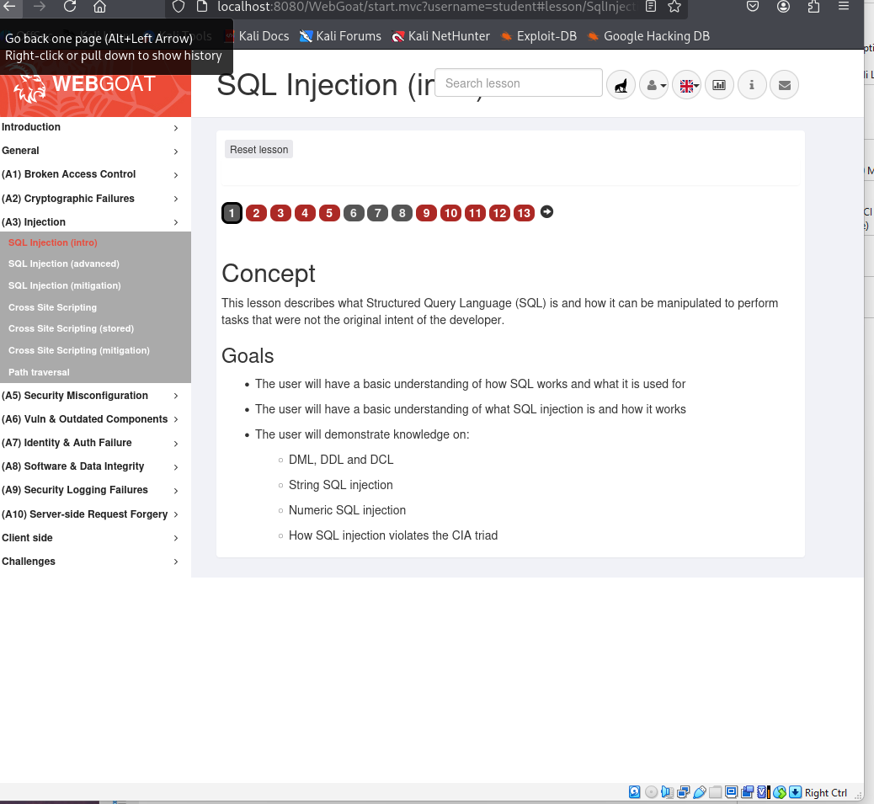
Availability Attack Completed Successfully
This is the final task shown in the screenshot.
The goal:
Compromise availability by deleting an audit table named access_log.
The vulnerable field allowed injecting this SQL command:
; DROP TABLE access_log;
WebGoat responded:
successfully deleted the access_log table and that way compromised the availability of the data.
This proved how SQL injection can destroy critical data and disable system functionality.
